# Foundry SSO and SLO with SAML Tracer

When you configure [SAML single sign-on with Foundry](https://resources.everfi.com/help/technical-integrations/sso/), occasionally there may be an issue that requires troubleshooting. EVERFI can help you most effectively by examining a trace of the SAML messages that are exchanged between EVERFI Foundry and your identity provider (IDP) during single sign-on (SLO) and single logout (SLO).

This document explains how you can run single sign-on (and possibly single logout) in Firefox or Chrome, record the SAML messages, and send the log (two separate files) to EVERFI for closer examination.

These instructions illustrate a complete end-to-end session of SSO and SLO. If you are not able to complete the full cycle from beginning to end because of errors, just get as far as you can and send us what you have.

It may take a couple of attempts to get this right. If possible, please be sure to start your SSO and SLO session with a blank SAML Tracer log; you can clear the log by clicking the **Clear** button in SAML Tracer. This will help us troubleshoot faster.

1. Run Firefox or Chrome browser

If your computer doesn’t have Firefox or Chrome, install it at [Download Firefox](https://www.mozilla.org/en-US/firefox/new/) or [Download Chrome](https://www.google.com/chrome/). Why these browsers? Because both have an excellent browser add-in/plugin that conveniently captures and logs SAML messages in a way that can be exported and shared.

1. Install SAML Tracer add-in/plugin in your Browser

Firefox [SAML Tracer](https://addons.mozilla.org/en-US/firefox/addon/saml-tracer/) add-in page

Chrome [SAML Tracer](https://chrome.google.com/webstore/detail/saml-tracer/mpdajninpobndbfcldcmbpnnbhibjmch?hl=en) plugin page

3. Record SP-initiated SSO and SLO

3.1. First, start a new browser session and make sure you are logged out of your identity provider and Foundry (the service provider).

3.2. In your browser, go to the **Customer Login Page** in Foundry to start your session. This URL varies for each organization but in general it should be similar to this:

[https://admin.fifoundry.net/**org_slug**/sign_in](https://admin.fifoundry.net/org_slug/sign_in)

where **org_slug** is a short code that is specific to your organization.

3.3. On the browser toolbar, click the **SAML Tracer** button to start your Tracer session.

3.4. You will see a new SAML Tracer window pop open:

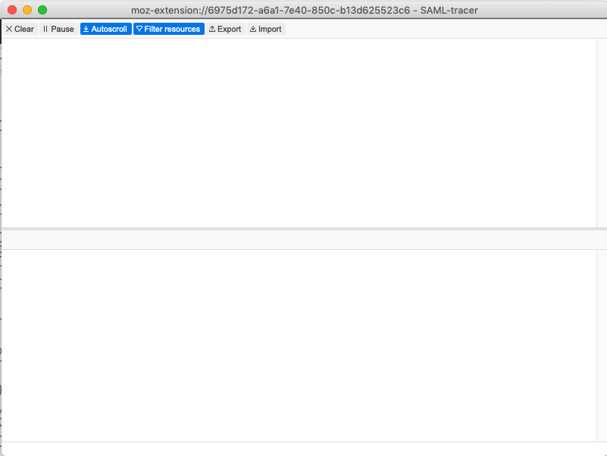

*SAML Tracer window*

3.5. Next, click the **SSO** button on the customer login page (the button’s text depends on how your IDP was set up in Foundry) to initiate a single sign-on.

Clicking this button will take you to your organization’s single sign-on page. This illustration shows an identity provider called Okta, but your own organization’s sign-on page will be different:

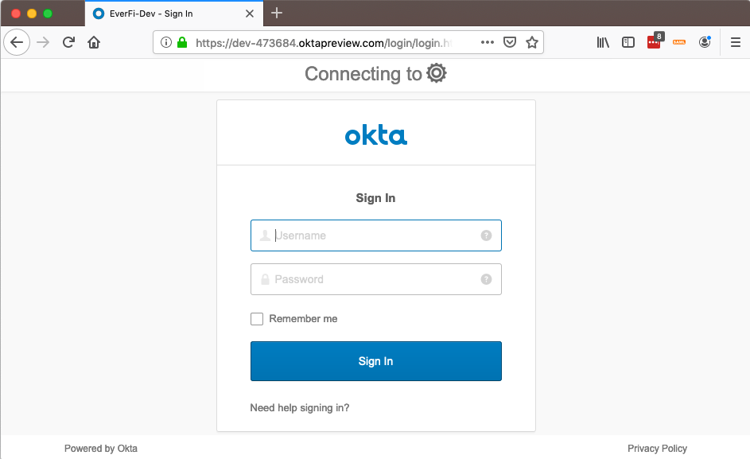

*Sample identity provider sign in page*

In SAML Tracer window, notice that the various browser actions have been logged:

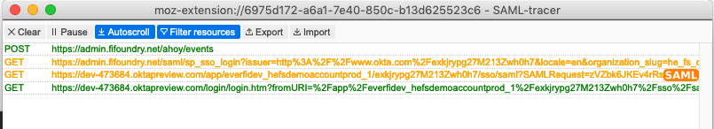*SAML Tracer window with logs*

Looking at the 3rd line, notice the orange **SAML** label on the right.

If you click your mouse cursor on this line, you can view this particular message in more detail. On the bottom pane, click the **SAML** tab to see the text of the SAML message that was delivered:

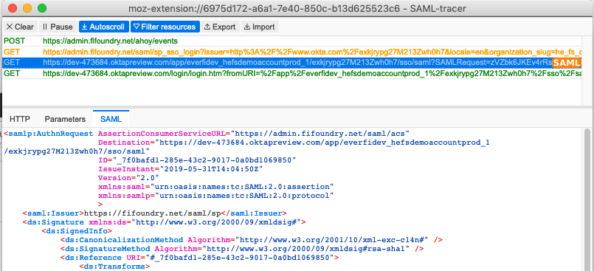

3.6. Next, log in to your IDP, after which you will be redirected back to Foundry and you should arrive on the Foundry learner dashboard. This completes the single sign-on sequence. You will see more logs in the SAML Tracer window:

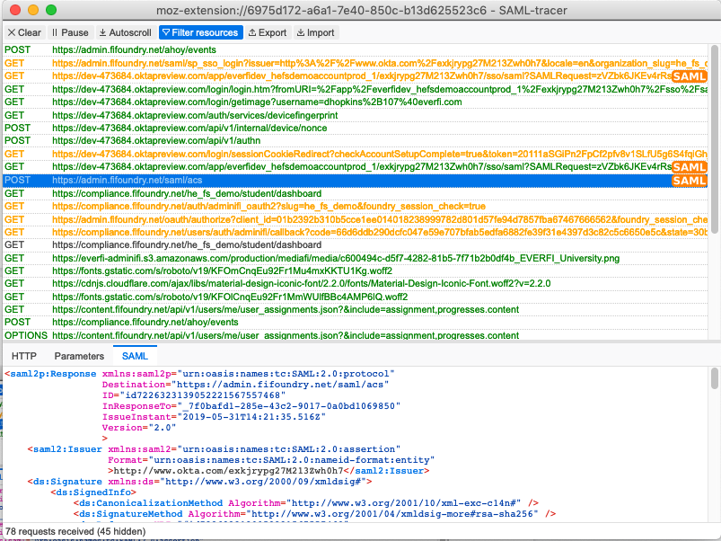

3.7. Finally, in Foundry, click the **logout** button to run SAML single logout. Although you might not have configured your instance to use SLO, go ahead and run the logout anyway.

This completes the SAML activities for the SP-initiated SSO and SLO section.

3.8. In the SAML Tracer window, click the **Export** button on the SAML Tracer menu at the top:

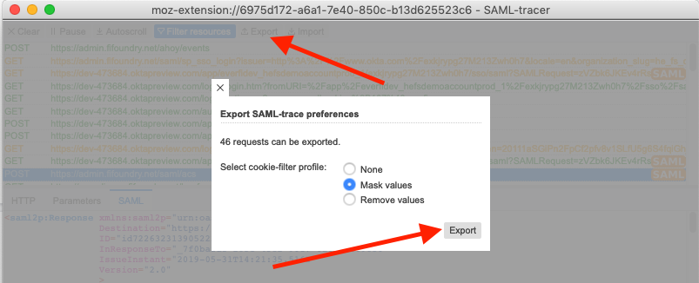

*SAML Tracer export function*

3.9. Save the export file and then send the downloaded file to your EVERFI contact.

4. Record IDP-initiated SSO and SLO

This sequence of steps records the SAML messages that are exchanged between your organization’s identity provider and Foundry during IDP-initiated SSO and SLO. These steps are similar to that of Section 3, only the SSO flow starts from your identity provider instead of from Foundry.

4.1. Navigate to your IDP portal from which SSO initiates. If you are not logged in to your IDP, log in. This page illustrates the IDP portal from Okta, but each IDP will have a different version.

4.2. In SAML Tracer, click the Clear button to clear any previous logs.

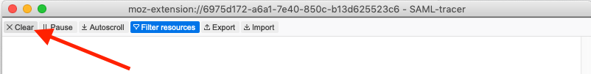

*SAML Tracer* ***Clear*** *button*

4.3. Moving back to your organization’s IDP dashboard page, click the tile for the Foundry app to launch IDP SSO

4.4. You should land on the Foundry customer learning page, if SSO succeeds.

4.5. Log out of your IDP. This completes the SSO and SLO session.

4.6. As shown in step 3.8 above, export the Tracer logs, save them to your computer and send them to your EVERFI representative.