Okta Single Sign-On Integration to EVERFI Foundry

*We strive to keep these guidelines up to date and relevant but be aware that software changes continually and therefore these steps may change over time. If you see a discrepancy, please let us know.*

# Summary

This document demonstrates how to set up SAML single sign-on and single logout (optionally) for EVERFI as a service provider and your organization’s Otka instance as an identity provider. After you complete this setup successfully, your organization’s users will be able to access EVERFI content and have EVERFI securely and seamlessly authenticate their identity through your organization’s identity provider.

These are the main steps you will do:

1. In EVERFI Foundry, download the EVERFI certificate file that will be needed in Okta. Also, gather necessary SAML SP properties for Foundry that you’ll need in Okta.
2. In Okta, create an App for Foundry. Get the IDP metadata URL for this App as this will be needed later in Foundry.
3. In Otka, assign Groups to the App.
4. Back In Foundry, add an identity provider configuration by linking to the SAML metadata URL for the EVERFI App in Okta, and configuring a few additional settings. Optionally, map Okta attributes to corresponding EVERFI attributes.

# Part 1: Gather EVERFI Certificate and Metadata

In this section, you will get a certificate file for the Foundry EVERFI X.509 certificate. In Okta, you will need to upload this certificate file if you want to encrypt assertions or set up single logout (SLO). If you don’t want to encrypt assertions or set up SLO, then you can skip this step.

You also must get three additional SAML properties from Foundry. We recommend you copy and then paste them into a text file for use later on.

1. Login to Foundry as an admin user, navigate to **Settings → Single Sign-On**
2. Click the **View** link next to EVERFI SAML Metadata.
3. From the EVERFI Metadata page, click **Download encryption certificate** to save a certificate file to your local environment.
4. Copy then paste into a text file the properties for Entity ID, ACS URL and SLO URL for later use.

# Part 2: Okta - Add App

1. In Okta, log in as an administrative user who has permissions to add Apps.
2. In Okta, click the **Admin** button.

*Note: the next steps are from the Okta* ***Classic UI*** *interface option.*

1. From the Admin dashboard, click **Applications** from the nav menu.
2. From the Applications section, click **Add Application.**
3. Click **Create New App**.
4. On the **Create a New Application Integration** popup window, for **Platform** choose **Web** and for **Sign on method** choose **SAML 2.0**, then press **Create**.
5. You are now in the **Create SAML Integration** wizard. Enter an **App name** like “EVERFI” and upload the EVERFI Logo located at [EVERFI logo](https://shib.everfi.net/EverFi_Logo_Home.jpg) (download the image file from the link, then upload it to Okta), then click **Next**.
6. Now you are on the **SAML Settings** page. In **Single sign on URL**, enter the ACS URL value you got earlier from EVERFI.
7. Leave the defaults for **Use this for Recipient URL and Destination URL** (checked) and **Allow this app to request other SSO URLs** (unchecked).
8. In **Audience URI (SP Entity ID)**, enter the EntityID value you got earlier from EVERFI.
9. In **Name ID format**, leave the default of **Unspecified**.
10. In **Application username**, choose the Otka property you want to send to Foundry as the username. The Foundry users must have this value in the **SSO ID** field for SSO to succeed. See [SAML NameID and EVERFI SSO ID](https://foundrysupport.everfi.com/knowledgebase/sso-saml-nameid-and-everfi-sso-id/) for more details.
11. Click **Show Advanced Settings** to display additional settings
12. In **Response**, choose **Signed** (the default)
13. In **Assertion Signature**, choose **Signed** (the default)
14. In **Signature Algorithm**, leave the default setting unless you wish to change.
15. In **Digest Algorithm**, leave the default setting unless you wish to change.
16. For **Assertion Encryption**, we recommend **Encrypted**. If you run into issues where you need to troubleshoot, you might want to temporarily change it Unencrypted to see the cleartext assertions in diagnostics but remember to switch it back to Encrypted when done.
17. If you chose to Encrypt the assertion, then in the next fields, enter the **encryption algorithm**, **key transport algorithm**, and in **encryption certificate,** upload the EVERFI certificate you downloaded earlier.
18. If you wish to **Enable Single Logout**, then check this box. As of this writing, we have observed that Okta supports SP-initiated SLO but not IDP-initiated SLO[1]. Later, be sure to also check the **Also log users out of this provider when logging out of Foundry** checkbox in the Foundry IDP setup described in Part 4.
19. If you chose to Enable Single Logout, then enter the **Single Logout URL** you got earlier from the EVERFI SAML metadata.
20. If you chose to Enable Single Logout, then enter the **SP Issuer** from Step 8a.
21. If you chose to Enable Single Logout, then for **Signature Certificate**, browse for the EVERFI certificate you downloaded earlier, and click **Upload Certificate**.
22. In **Attribute Statements**, add any SAML attributes you wish to send to Foundry if you desire for new users to get created during SSO.

*If your Foundry users will be added/uploaded separately from SSO, then skip this step. If you wish for new users to get automatically created for just-in-time user provisioning during SSO, then continue following the instructions in this step. Generally, organizations who are in code and conduct can skip this section because your organization will upload your users into Foundry and not create them during SSO.*

If you wish to have SSO create new users in Foundry, then you **must** provide attributes for:

* first name
* last name
* email address. Even if you already provided email as the Okta username, you still must add this again as a regular attribute.

If you wish to have SSO create new users in Foundry, then you *may* also provide claims for:

* Location - be sure to map to a Okta value that contains the same exact **location name** as it is in Foundry (not ID). Location name is case sensitive.
* User Type (for example fac_staff_learner for a faculty/staff learner or cc_learner for a code and conduct learner)
* Role - for example, supervisor or non_supervisor, but exact values may vary depending on the UserType and your line of business

You can name the attributes anything you wish; later on, in Foundry, you’ll need to specify those attribute names. If you do not provide any of the 3 optional claims listed above, then Foundry will provide defaults instead based on the settings in the Foundry identity provider configuration.

If you want to specify the user’s role, then the assertion **must** also specify the User Type, even if the User Type is the same as the default user type in the IDP configuration. See the table below for the various User Type + Role combinations depending on your organization's line of business:

|  |  |  |  |
| --- | --- | --- | --- |
| **Line of Business** | **Group of People / User Type** | **User Type Attribute Value** | **Role Attribute Value (choose 1)** |
| Faculty & Staff | Faculty and Staff who will take courses who are “Faculty/Staff Learner” | fac_staff_learner | supervisor  non_supervisor |
| Code & Conduct | “Employee Learners” | cc_learner | supervisor  non_supervisor |
| Adult Financial Services | Learner | next_learner | default |

### Setting Supervisor or Non-Supervisor Role



|  |
| --- |
| *This section is a case study illustration. Your organization’s own unique instance of Okta will be different from this. Refer to your own organization’s specific Okta settings when you configure the Foundry app and do not replicate this example letter-for-letter.* |

The one Attribute value that can be complex to set is the role. You will need to determine which property or condition in Okta means that a user is or is not a supervisor/manager. Depending on your Okta configuration, this might be a custom user property, or it could be based on belonging to a group, or it could be some other setting.

As an illustration, your Okta instance might have a custom user property called IsManager which is “true” or “false”; this value might be set by your separate user system (like LDAP). *This is just an example; your own instance of Okta is sure to be different.*

When you add the role attribute, you cannot simply set this to be the user.IsManager property because Foundry requires the Attribute value to be either supervisor or non_supervisor if the User Type is “Employee Learner” or “Faculty/Staff Learner”. Therefore you will need a [custom expression](https://developer.okta.com/docs/reference/okta-expression-language/) like this for the attribute Value:

(user.IsManager == 'true') ? 'supervisor' : 'non_supervisor'

Another possibility is that the user might be in a certain group, for example **HRManagers** (this is just a made-up example):

user.isMemberOfGroupName("HRManagers") ? 'supervisor' : 'non_supervisor'

When complete, the specific Attribute might look like the following in Okta. Note that the complete Value is clipped by the user interface.

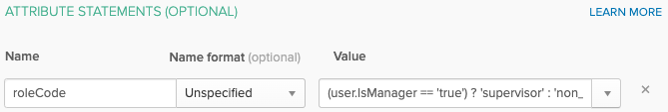

Remember that if you specify a **role**, then you must also specify the **User Type**.

Ultimately, you’ll want your Otka assertion XML to look like this, assuming that you have chosen to name the User Type Attribute userType and the role attribute roleCode:

|  |
| --- |
| <**saml2:Attribute** Name="userType"  NameFormat="urn:oasis:names:tc:SAML:2.0:attrname-format:unspecified"  >  <**saml2:AttributeValue** xmlns:xs="http://www.w3.org/2001/XMLSchema"  xmlns:xsi="http://www.w3.org/2001/XMLSchema-instance"  xsi:type="xs:string"  >cc_learner</**saml2:AttributeValue**> </**saml2:Attribute**> <**saml2:Attribute** Name="roleCode"  NameFormat="urn:oasis:names:tc:SAML:2.0:attrname-format:unspecified"  >  <**saml2:AttributeValue** xmlns:xs="http://www.w3.org/2001/XMLSchema"  xmlns:xsi="http://www.w3.org/2001/XMLSchema-instance"  xsi:type="xs:string"  >non_supervisor</**saml2:AttributeValue**> </**saml2:Attribute**> |

Looking at the Assertion XML above, if the learner is a Supervisor, then the AttributeValue will be supervisor instead.

The Attributes setup in Okta might look like this when you are done. Notice in this example that the userType attribute Value is hard-coded to cc_learner.

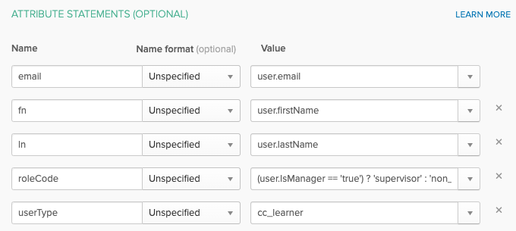

Given the Okta Attributes above, In Foundry, the Foundry identity provider configuration **Attribute Maps** section will look like the following setup below. Be sure that you name the SAML attributes the exact same as the attribute names you entered in Okta; attribute names are case sensitive. Note that the top-to-bottom sorting of the attribute names in Foundry doesn’t matter.

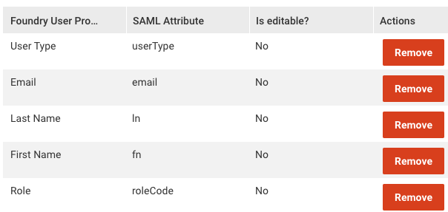

After setting up attributes, click **Next**

1. In **Help Okta Support understand how you configured this application,** fill in the various questions to assist Okta support if necessary.
2. Click **Finish**

You’ve now added the App for Foundry in Okta.

# Part 3: Okta Assignments

1. In Otka, assign any **Groups** and **People** to the EVERFI App you have just created. Remember that the User still must exist in Foundry to SSO, unless you enable the option for Foundry to create new users upon SSO.

# Part 4: Foundry Identity Provider Setup

Refer to EVERFI’s [general SAML documentation](https://foundrysupport.everfi.com/knowledgebase/sso-identity-provider-setup-steps/) for the setup you will need to do in Foundry to configure your identity provider settings.

With Otka, setting up the Identity Provider in Foundry is simple.

1. In Foundry, you will configure your organization’s SSO Metadata with the **Use a URL** option on the Foundry IDP setup page. The URL will be that of **Identity Provider Metadata** link that is on the **Sign On** tab of the App in Otka. You can “copy” this URL and then “paste” it into the Foundry setup page.

Enter the other properties as described in the documentation.

## Option to Create Users During SSO

*If your Foundry users will be added/uploaded separately from SSO, then skip this section. If you wish for new users to get automatically created during SSO, then continue following the instructions in this section. Generally, partners who are code and conduct can skip this section because your organization will upload your users into Foundry and not create them during SSO.*

1. In the Foundry IDP setup, check the “Allow automatic registration during SSO” checkbox.
2. Set up default values for new users for **user type**, **role** and **location** (omit location for financial education organizations).
3. In the **SAML Attribute Map** section, add Attribute maps for the Okta Attributes to the corresponding EVERFI attributes. Be sure to Save the identity provider after adding or updating the Attributes.

# Documentation Updates

|  |  |  |
| --- | --- | --- |
| **Version** | **Date** | **Update** |
| 1.0 | 06/04/2019 | First version of document |
| 1.1 | 9/9/2019 | Minor updates |
| 1.3 | 12/02/2019 | Minor updates |
| 1.4 | 3/5/2020 | Correct error relating to certificates. The certificates to upload into the Foundry App are the Foundry certificates. |
| 1.5 | 4/9/2020 | Add more details  Provide detailed instructions on User Type and Role attributes |

This table and the document name will be updated whenever significant changes are made to this document. This versioning is for the documentation itself, not for the actual software products.

1. [Is IDP-initiated Single Log-Out supported? | Okta Knowledgebase](https://support.okta.com/help/s/article/Is-IDP-initiated-SLO-supported) “Question: Is IDP-initiated Single Log-Out supported? Answer: No. Only SP-initiated SLO is supported.” May 13, 2020